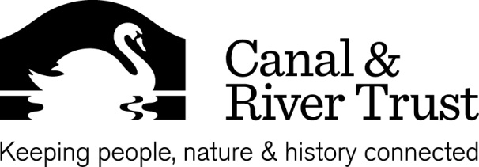

ANNUAL MEETING NOTIFICATION

LONDON WATERWAY PARTNERSHIP ANNUAL MEETING
3RD JULY 2013,

There is an opportunity to attend our London Waterway partnership Annual Meeting which is being hosted by Wolff Olins ,10 Regents Wharf, All Saints Street, London, N1 9RL. The meeting will be between 6:00pm and 7:00pm on wed 3rd July 2013. Please use this link for the location map
The meeting will explain what the London Partnership has achieved since its inception and to show what’s been going on with the draft Strategic Plan for the Waterway priorities over the next 10 years.
Following the meeting there will be opportunity to Network with colleagues and Partnership members from 7:00 to 8:00pm
Places are limited so to reserve your place please send an e mail to katy.gavan@canalrivertrust.org.uk.
If the event is oversubscribed we will allocate places on a first come, first served basis.
We look forward to seeing you
Sir Brian Fender
Chair of London Waterway Partnership
London Waterways
Canal & River Trust Docklands 420 Manchester Road London E14 9ST
T 0303 040 4040 E enquiries.london@canalrivertrust.org.uk www.canalrivertrust.org.uk
Patron: H.R.H. The Prince of Wales. Canal & River Trust, a charitable company limited by guarantee registered in England and Wales with company number 7807276 and registered charity number 1146792, registered office address First Floor North, Station House, 500 Elder Gate, Milton Keynes MK9 1BB

